Circuit Diagram
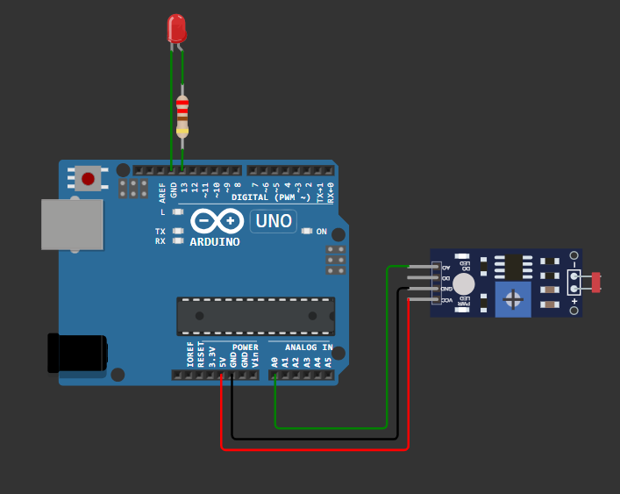
Source of Code
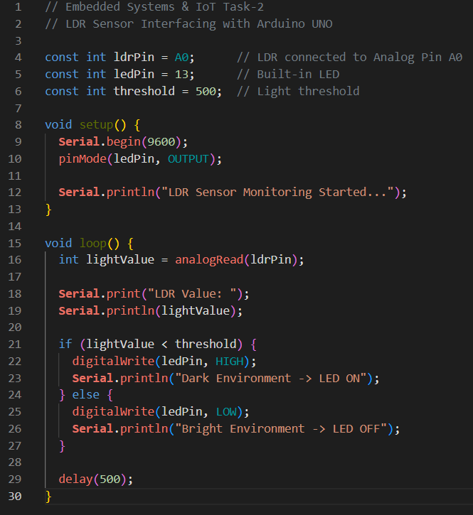
Explanation
The Passive Infrared (PIR) sensor is a motion detection device that senses changes in infrared radiation emitted by warm objects, such as the human body. Unlike active sensors, it does not emit any signals; instead, it passively monitors the surrounding environment. Under normal conditions, the sensor output remains LOW. When a person or any warm object moves within the sensor's detection range, the infrared pattern changes, causing the sensor output to become HIGH. This signal is used by the Arduino to detect the presence of motion and perform the required action.
The Arduino program continuously reads the digital output of the PIR sensor using the digitalRead() function. If the sensor detects motion and the output becomes HIGH, the Arduino immediately turns the LED ON and displays the message "Motion Detected" on the Serial Monitor. When no motion is detected, the sensor output remains LOW, the LED stays OFF, and the message "No Motion Detected" is displayed. A short delay is included in the program to improve the stability of the sensor readings and prevent repeated or unnecessary detections.

